BOTINKIT 2.0 Site Requirement Standard Operating Procedure

Site preparation instructions
Dear user:  Thank you for choosing BOTINKIT’s cooking robot!  A good environment is an important condition to ensure the continued operation of equipment and systems. Please carefully read the user preparation section in the following table (under Equipment specifications and parameters table) to prepare the power supply and water source.  After completing the preparations, please fill out the "Installation Site Inspection Receipt" and notify BOTINKIT by email or fax. BOTINKIT will arrange engineers to go to the site to provide installation services. | BOTINKIT Support Center:  Phone: 400 993 7576  Email: service@botinkit.com

Equipment specifications and parameters
Equipment model | BOTINKIT 2.0
Equipment specifications (including base)  Height * Width* Depth (mm ) | Specifications (Without Packaging): Main Equipment: 832*970*1768mm.
Main Equipment | Equipment name and quantity | Equipment name and quantity
Main Equipment | Robot x 1 | Cooking Pot x1
Gross weight | - MAX (Without Pot): 183kg  - MAX Pro (Without Pot): 200kg  - Pot: 10kg
User preparation section
Recommended specifications for AC power supply | - The above is for reference only. Please refer to the actual situation accordingly.  1. It is recommended to install the leakage protection device on the right rear side of the robot, within 1.5m distance from the robot.  2. Each machine requires an independent leakage protection device and power supply.
  Local Voltage | Recommended Electrical Box Configuration | MAX Electrical Power | Recommended reserve current | Recommended Leakage Protection parameters | Recommended wire specifications (copper)
  220V | 3 Phase 4 Wires | 10kW | 34A | ≥40A | 3 live wires, 6mm²  1 ground wire, 2.5mm²
  220V | 3 Phase 4 Wires | 12kW | 40A | ≥50A | 3 live wires, 8mm²  1 ground wire, 2.5mm²
  380V | 3 Phase 5 Wires | 12kW | 24A | ≥25A | 3 live wires, 6mm²  1 neutral wire,6mm²  1 ground wire, 2.5mm²
  380V | 3 Phase 5 Wires | 15kW | 30A | ≥40A | 3 live wires, 6mm²  1 neutral wire, 6mm²  1 ground wire, 2.5mm²
  Note: 4mm²= 12AWG; 6mm²= 10AWG; 10mm² = 8AWG; 16mm²=6AWG
Inflow | - The recommended water pressure range for robot water pressure is: 200 to 350 KPA.  - Individual quarter-inch inlet valve fittings for each equipment.  - The water inlet valve should be within 1 m of the machine.
Recommended Exhaust Hood | - It is recommended that hood exhaust power for one machine should not be less than 3500 m³/h.  - It is recommended that the top of the equipment and the exhaust hood distance should be within 200-300mm, with a depth should not less than 1300mm.
Drainage | For PVC drainage pipe (center side of base)  - The height of the drainage outlet from the ground should be less than or equal to 390mm.  - The diameter of the drainage outlet should be greater than or equal to 500mm.  - The horizontal distance from the drainage outlet to the machine should be less than or equal to 500mm.
Reserve Space | - It is recommended to reserve 150mm behind the robot, 250mm on both left and right sides, and 500mm in front of the robot.  - In the absence of heat sources, reserve at least 120mm behind the robot, 50mm on both left and right sides, and 500mm in front of the robot  - Please ensure the site space is sufficient for robot transportation  - If elevator transportation is required, please confirm the elevator's load capacity
Other things to note | - Ensure that the WiFi is stable and has good signal strength.  - Ensure there are no factors near the installation that could affect machine functionality, such as staying away from equipment that produces large amounts of steam (steam can cause solid components to solidify and block drainage outlets).  - Ensure there is no heat sources within 1.5m range.  - Ensure there are no corrosive substances within 1.5m range.

Equipment installation Diagram
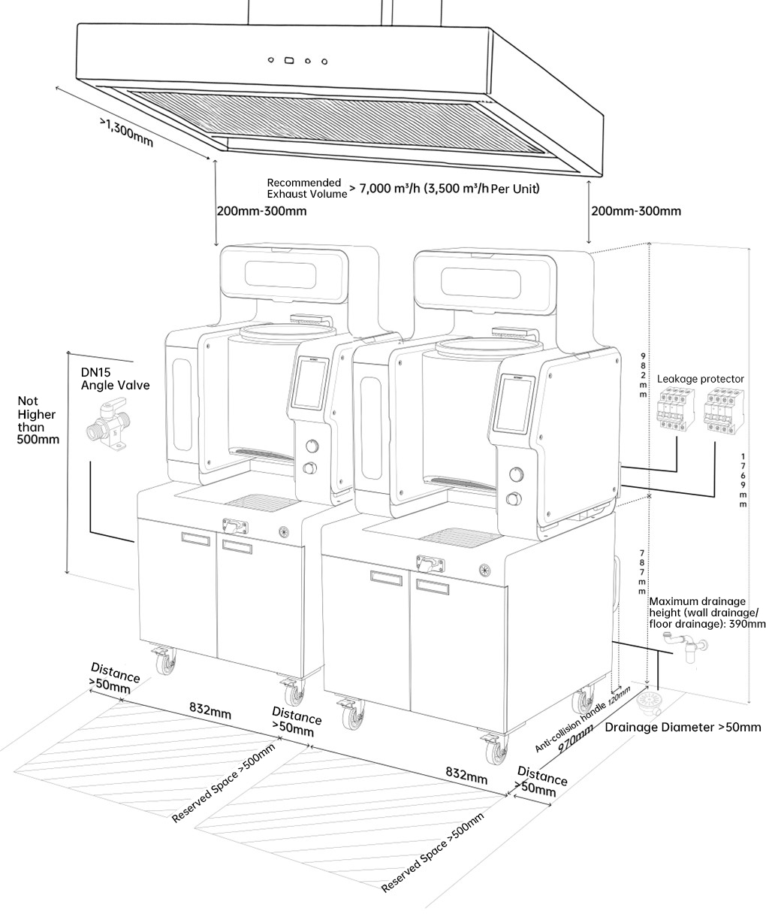

Equipment installation Diagram
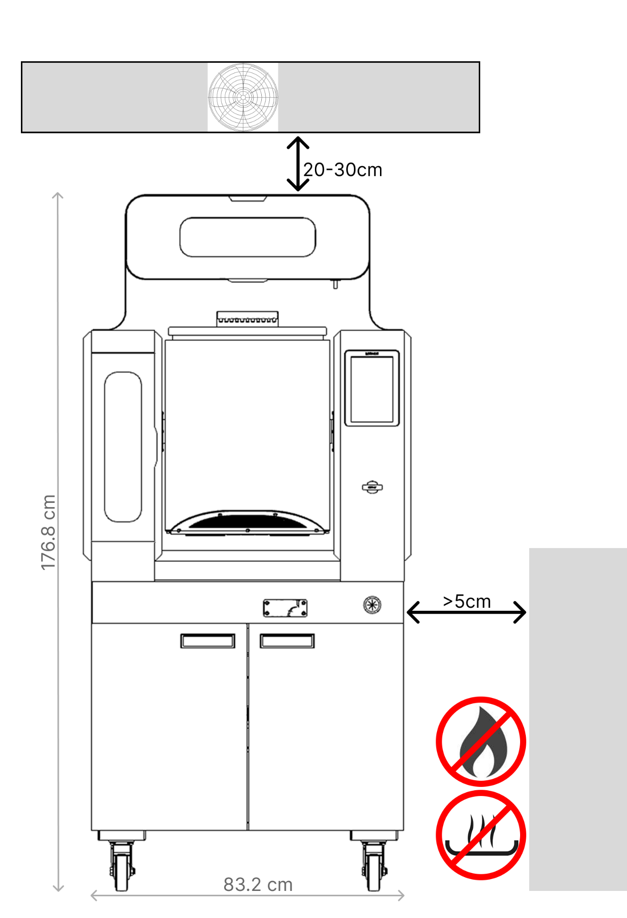

Equipment installation Diagram
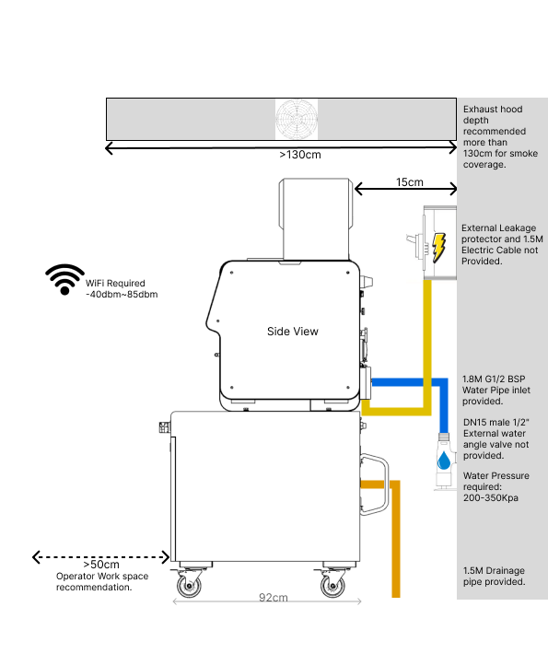

Site Requirement Checklist
User Information
Order number (contract number) |  |  |  | User Organization Name
User installation contact/contact number |  |  |  | Required installation date
Installation Site Preparation Checklist
Transportation and installation environment requirements |  |  |  |  |  | Check the results
1 | The kitchen has reserved areas for equipment placement, and sufficient maintenance space has been reserved in the front and back. (Under non-heat source conditions, reserve at least 50mm on both sides, 500mm in front, and 120mm at the back) |  |  |  |  | Yes( ) No( )
2 | The width and height of all passages or door frames that the transportation passes through meet the transportation requirements. (Narrowest position 850mm, height ≥ 1800mm) |  |  |  |  | Yes( ) No( )
3 | When moving the equipment, the floor or elevator must be able to support the weight of the equipment. (MAX requires at least 193KG load capacity, MAX Pro requires at least 200KG load capacity, and the weight of personnel handling the equipment should also be considered) |  |  |  |  | Yes( ) No( )
4 | Check whether there are gas pipelines, water supply pipelines, drainage pipelines, etc. passing through the installation area (the height shall not exceed 100 mm ). |  |  |  |  | Yes( ) No( )
Please take photos of the area prepared for equipment placement
Power supply, distribution and grounding
1 | Are all the power supplies required by the device available ? |  |  |  |  | Yes( ) No( )
2 | Whether the device charge load requirements are met. |  |  |  |  | Yes( ) No( )
3 | Have power lines for electrical loads been reserved? |  |  |  |  | Yes( ) No( )
Please take photos of the power supply leakage protector and power supply line.
Equipment water supply and drainage requirements
1 | Check whether there is a water supply port in the installation area and whether an independent DN15 water valve is installed in the water supply port. |  |  |  |  | Yes( ) No( )
2 | Please use a water pressure gauge to measure and observe whether the water pressure is within the required range (200 to 350 kPa). If it does not meet the requirements, you need to contact us to install a pressure reducing valve. |  |  |  |  | Yes( ) No( )
3 | According to the type of drainage pipe, whether there is an appropriate drainage port height and drainage port diameter. |  |  |  |  | Yes( ) No( )
Please take photos of the water supply and drainage.
Exhaust Fumes
1 | The exhaust fumes functions properly, the ventilation is normal and there is sufficient ventilation power. |  |  |  |  | Yes( ) No( )
Please take photos of the exhaust hood/range hood.
Other
1 | Is there a wireless network to log in to Botinkit App? |  |  |  |  | Yes( ) No( )
2 | Is the ground at the installation location flat? |  |  |  |  | Yes( ) No( )
Please take photos of other special circumstances.
Are there any other issues during the installation ? |  | None ( ) / Question: ____________________________________________________________

Photo Documentation Checklist:
1 | Area prepared for equipment placement
2 | Leakage protector and power supply line
3 | Water supply and measure water pressure values
4 | Drainage
5 | Exhaust hood
6 | Other special circumstances

User Signature: Date:

Please note: This manual only describes the equipment installation and operating environment of the BOTINKIT robot. The final right of interpretation belongs to BOTINKIT.

